Chapter 26 AVL Trees and Splay Trees
1. AVL trees are well-balanced. In an AVL tree, the difference between the heights of two subtrees for every node is 0 or 1.
The balance factor of a node is the height of its right subtree minus the height of its left subtree. A node is said to be balanced if its balance factor is -1, 0, or 1. A node is said to be left-heavy if its balance factor is -1. A node is said to be right-heavy if its balance factor is +1.
- If a node is not balanced after an insertion or deletion operation, you need to rebalance it. The process of rebalancing a node is called a rotation. There are four possible rotations: LL, LR, RR, and RL.

An LL imbalance occurs at a node A such that A has a balance factor -2 and a left child B with a balance factor -1 or 0. This type of imbalance can be fixed by performing a single right rotation at A.
- In the BinaryTree class, the createNewNode() method creates a TreeNode object. This method is defined protected in BinaryTree. It is overridden in the AVLTree class to create an AVLTreeNode.

- updateHeight(AVLTreeNode<E>) is invoked to update the height of a node. It is invoked to rebalance the tree. balanceFactor is invoked to check the balance factor of a node. It is invoked when a path is rebalanced. balancePath is invoked along the path where a new node is inserted or a node is deleted.

- AVLTreeNode inherits from TreeNode. The height is a new data field defined in AVLTreeNode. The data fields in TreeNode are left and right, pointing to the left and right subtree.

- No.

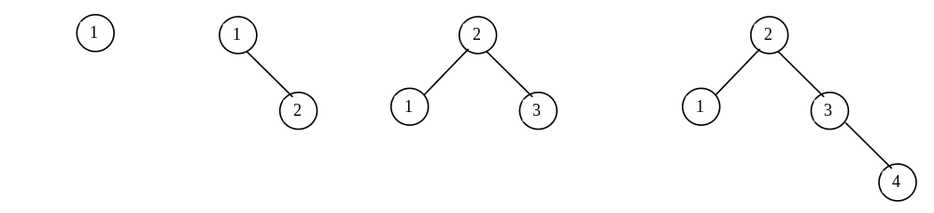

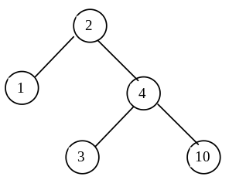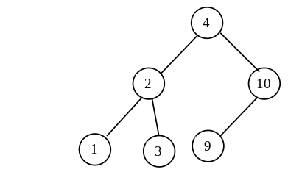
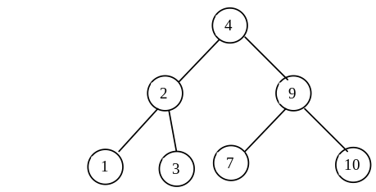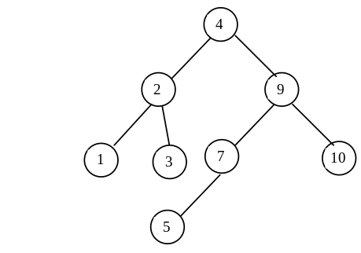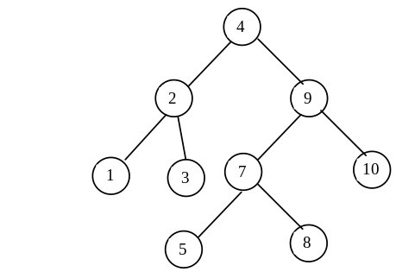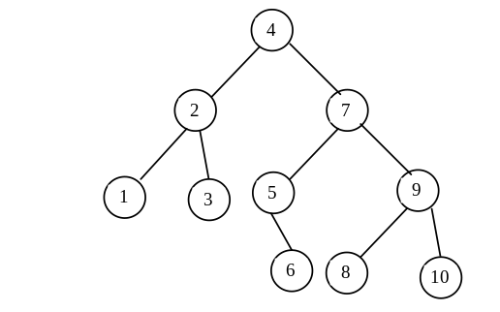

8.
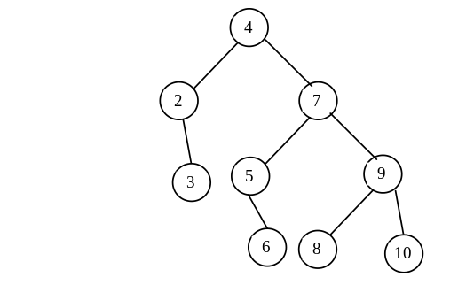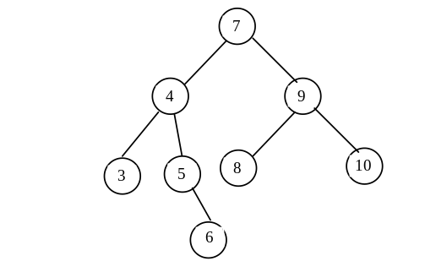

Please verify your answers using the animation tool.

9.
Please verify your answers using the animation tool.

10.
Please verify your answers using the animation tool.

11. Insert 1, 2, 3, 4, 5, 6.

